BIOLOGICAL CONTROL OF THE CYCAD AULACASPIS SCALE, AULACASPIS YASUMATSUI

Ronald D. Cave¹, Aubrey Moore², and Mark Wright³

¹Indian River Research and Education Center, Institute of Food and Agricultural Sciences
University of Florida, Ft. Pierce FL 34945
rdcave@ufl.edu

²College of Natural and Applied Sciences, University of Guam, Mangilao GU 96923
aubreymoore@triton.uog.edu

³Department of Plant and Environmental Protection Sciences, University Hawaiʻi at Mānoa,
Honolulu HI 96822
markwrig@hawaii.edu

NON-TECHNICAL SUMMARY

The cycad aulacaspis scale, Aulacaspis yasumatsui, is a worldwide pest of cycads. In Florida, Hawaiʻi, and elsewhere, cycads are planted as urban landscape plants and exported for sale as potted plants. The scale has decimated the cycad production industry and reduced the use of the king sago, Cycas revoluta, and other cycads as ornamental plants. On western Pacific islands, the scale is destroying populations of native Cycas micronesica. The invasion of Guam by the cycad aulacaspis scale has led to the death of at least 90% of the island’s C. micronesica trees. The parasitic wasp Coccobius fulvus and the predatory beetle Cybocephalus nipponicus were released in Florida and became established, but do not provide satisfactory control of the pest. The parasitic wasp Arrhenophagus chionaspidis was first detected attacking cycad aulacaspis scales in Florida in 2012, but its influence on pest populations has not been evaluated. In Hawaiʻi, the lady beetle Rhyzobius lophanthae seems to be a good biological control agent as it can be effective under a range of conditions. The parasitic wasp Aphytis lingnanensis, or a cryptic species very similar to it, may have a significant effect on cycad aulacaspis scale populations in Hawaiʻi, where infested plants seem to survive the presence of the scale insect when the parasitoid causes high levels of scale mortality. Rhyzobius lophanthae was introduced in Guam and is established but does not protect young plants. Arrhenophagus chionaspidis occurs in Guam and appears to cause high rates of parasitism on leaves. Attempts to introduce C. fulvus and the Hawaiian Aphytis species to Guam were unsuccessful. Foreign exploration in Asia discovered the lady beetle Phaenochilus kashaya, which may be an effective biological control agent, but there are no current plans to introduce this predator on western Pacific islands. Introductions of Aphytis species from Hawaiʻi and C. nipponicus from Florida may offer hope to save the native C. micronesica in Micronesia.

HISTORY OF INVASION AND NATURE OF PROBLEM

The Species Invasion

The cycad aulacaspis scale, Aulacaspis yasumatsui (Hemiptera: Diaspididae), was discovered infesting cycads in 1994 in the Montgomery Botanical Center in southern Florida after unknowingly being brought to the Center on cryptically infested plants imported from Southeast Asia (Tang et al., 2006), where it is native (Takagi, 1977). Infestations of the scale were particularly severe on Cycas spp. and Stangeria eriopus (a South African cycad in a monotypic genus). From this single infestation point, the scale spread throughout Florida and into other southeastern U.S. states and Texas. Hawaiʻi became infested with the cycad aulacaspis scale by 1998, when the pest was detected on Oahu, and the scale has subsequently been found on the islands of Hawaiʻi and Kaua’i (Heu et al., 2003). The scale was found in Guam in 2003 on ornamental king sagos (Cycas revoluta) (Terry and Marler, 2005). Within two years, the scale spread throughout most of Guam and invaded the native forests of Cycas micronesica, an indigenous tree unique to Micronesia (Moore et al., 2005a). The pest was discovered on Rota in 2007 (Calonje, 2008) and Palau in 2008 (Orapa and Cave, 2010). The cycad aulacaspis scale is now established in many tropical and subtropical regions and countries, including the West Indies, Mesoamerica, New Zealand, Indonesia, Singapore, Philippines, China, Vietnam, Micronesia, West and South Africa, and southern Europe (Howard et al., 1999; Weissling et al., 1999; Hodgson and Martin, 2001; Moore et al., 2005a; Bográn et al., 2006; Germain and Hodges, 2007; Segarra-Carmona and Pérez-Padilla, 2007; Marler, 2012; Muniappan et al., 2012; Normark et al., 2017; Dimkpa et al., 2021; Marler et al., 2021). The dispersal factor responsible for this broad distribution is the intracontinental commercial movement of cycads, but private collectors may in part be another pathway for spread. The presence of cycad aulacaspis scales on the leaves is easily visible, but the insect can cryptically occupy coralloid roots (Fig. 1A), excised leaf bases on trunks, and cataphylls covered by tomentum (Fig. 1B), where it is difficult to be seen by phytosanitary inspectors (Marler and Moore, 2010).

Nature of the Problem

The sessile adult female scale creates a round, white armor under which it feeds by using piercing-sucking mouthparts and produces eggs (Fig. 2). From the eggs emerge tiny nymphs, called crawlers (Fig. 2), that have functional legs but do not feed. The crawlers walk to other plant parts or adjacent host plants, or they can be dispersed to other host plants by wind. When the crawler finds a suitable site on the plant, it settles and molts to the next stadium that has no legs but does have functional piercing-sucking mouthparts. While it feeds, the sessile scale secretes a substance that forms the armor covering the insect. Male scales produce a white, three-ridged covering (Fig. 2) under which the male molts and eventually emerges as the tiny adult male with one pair of wings (Fig. 2) but no functional mouthparts. Females secrete additional covering material, mate with mobile males, and then produce eggs to repeat the life cycle.
All plants in the family Cycadaceae and several species of Zamiaceae are hosts of the cycad aulacaspis scale (Marler et al., 2021). Uncontrolled, the scale forms dense populations on the trunk, roots, seeds (Fig. 1C), and leaves (Fig. 1D). Feeding by dense scale populations deprives the host plant of nutrients, weakening the plant, which may die of plant pathogens that healthy plants could tolerate or resist.
Based on an island-wide census of Guam’s trees by the US Forest Service in 2002, the year before the arrival of the cycad aulacaspis scale, the tree cycad C. micronesica was identified as the most abundant tree in Guam’s forests (Donnegan et al., 2004). Within 12 years of the scale’s invasion, C. micronesica was listed as endangered under the U.S. Endangered Species Act. Rapid decline of the C. micronesica population in Guam was documented by Marler and Krishnapillai (2020) (Fig. 3). Cycad stem count declined to only 12.5% of the original count within the first three years of survey work (2005–2008), and this decline continued as it reached just 4% of the original count in succeeding years (2009–2020). In addition to high plant mortality, surviving cycads stopped reproducing in the research plots on Guam. The last seedling (0–10 cm tall) was seen in 2006, and the last juvenile (10–100 cm tall) was seen in 2014. In some areas of Guam, the mortality rate of 100-year-old C. micronesica trees has reached 100%.
Secondary effects of cycad aulacaspis scale on the health of C. micronesica are not obvious. Perhaps the most important secondary impact is much lower reproductive capability in plants recovering from scale infestation. Seeds from scale-infested plants are deficient in nonstructural carbohydrates, and germination rates are much lower, i.e., 43% of seeds from healthy plants germinate versus 7% of seeds from infested plants (Marler and Cruz, 2019). In addition, Marler and Terry (2021) reported that mature male plants that survive the initial scale infestation have significantly smaller cones than healthy plants.
Marler (2013) reported on results of nondestructive stem-winching stress tests performed on C. micronesica trees to simulate the effects of typhoon strength winds. Stems of plants that had not been infested by cycad aulacaspis scale were significantly stiffer than those that had been infested by the scale for either two or five years. Marler hypothesized that scale-infested plants would be more susceptible to stem failure during typhoons. Evidence supporting this hypothesis came two years later when Typhoon Dolphin passed over Guam on May 15, 2015. Marler et al. (2016) compared the level of damage from Typhoon Dolphin with that of a previous cyclone, Supertyphoon Paka, that damaged Guam’s forests in 1997 when the C. micronesica population was healthy. Less than 2% of the healthy C. micronesica population exhibited windsnap damage during Supertyphoon Paka’s peak winds of 298 km/h. In contrast, Typhoon Dolphin’s peak winds of only 170 km/h caused windsnap of 6% of Guam’s unhealthy C. micronesica population after only 10 years of infestations by the cycad aulacaspis scale.
Cycads are highly desired by landscapers and homeowners as ornamental plants because they are long-lived, require low maintenance, and are resistant to most pests. Cycad aulacaspis scale infestations on ornamental cycads are unsightly (Fig. 4). Cycas revoluta (the king sago), the most popular ornamental cycad, is particularly susceptible to the scale. Many ornamental king sagos throughout the world have died due to the cycad aulacaspis scale.

WHY CONTROL THIS INVASIVE SPECIES?

Populations of C. micronesica on several island groups (Guam, the Northern Mariana Islands, and other western Pacific islands) are now threatened by the cycad aulacaspis scale (Fig. 5). Currently, unhealthy mature C. micronesica plants in Guam’s forests are not producing seeds nor being replaced by juvenile plants. Without control of the invasive scale, this endemic plant, the most abundant tree in Guam’s forests only two decades ago, is headed towards local extinction. Marler and Lawrence (2012) predicted the extinction of C. micronesica from western Guam by 2019, but small pockets of large trees still struggle to survive. There is an urgent need to control cycad aulacaspis scale so that some recovery can take place, without further loss of biodiversity.
The disappearance of C. micronesica from Guam is likely to threaten the survival of other endangered organisms. The Mariana fruit bat, Pteropus mariannus, eats the fleshy, aromatic covering of C. micronesica seeds, which may be the bat’s sole food source after a typhoon destroys less wind-tolerant fruit-bearing plants such as papaya (Haynes and Marler, 2005). In 2020, the US Fish and Wildlife Service estimated that only 45 Mariana fruit bats remain in Guam in a single roost site on Andersen Air Force Base.
A moth, Anatrachyntis sp. (Lepidoptera: Cosmopterigidae), is a probable pollinator of C. micronesica and possibly an obligate symbiont, i.e., it cannot survive without the cycad. Larvae are numerous in male cones following pollen shedding, and they pupate in silken cocoons on the surfaces of cones (Marler and Muniappan, 2006). These authors hypothesized that the moth contributes to rapid degradation of the large and metabolically costly cone tissue after pollen dispersal. Terry et al. (2009) used sticky traps to sample insects and pollen in the vicinity of female C. micronesica cones. They observed that 30% of the pollen grains were associated with Anatrachyntis moths or moth scales and <5% with other insects; over 60% of the pollen was not associated with any insect, suggesting most pollen is dispersed by wind. Based on these observations, the authors hypothesized that Anatrachyntis sp. is an important pollinator of the tree.
Cycads are also economically valuable. The king sago is the most preferred ornamental cycad species in the international horticulture industry; nearly 110,000 plants were exported in 1993 (Whitelock, 2002). According to a report of the Convention on International Trade in Endangered Species, 99% of the 30 million cycads traded internationally from 1977 to 2001 originated from propagation nurseries (Anon., 2003a). Before 2003, 17 countries were involved in the international cycad trade (Anon., 2003b). Soon after the arrival of the cycad aulacaspis scale in Florida, exports of cycads from the state likely spread the scale internationally (Marler et al., 2021). All former cycad propagation nurseries in Florida have ceased production and export of the plants.

THE ECOLOGY OF THE PROBLEM

The cycad aulacaspis scale is a member of the armored scale family Diaspididae. Only two other species of Aulacaspis occur in North America, and both are considered agricultural pests. Aulacaspis rosae is a pest of roses, and Aulacaspis tubercularis is a pest of mangoes. Both species are adventive in North America and have a circumtropical distribution. There are no native species of Aulacaspis or other armored scales in either Hawaiʻi or Guam. Because the cycad aulacaspis scale is a non-native insect outside of Thailand, it is not a keystone species or a unique prey or host for any native predator or parasitoid.
Ecological harm by the cycad aulacaspis scale in Guam, Rota, Palau, and other Micronesian islands is threatening with destruction the ancient, once-extensive native forests of C. micronesica. The armored scale weakens cycad trees and reduces their resistance to tropical cyclone winds and delays recovery after a storm (Marler and Lawrence, 2013). Dead trees are not being replaced because the scale kills seeds and seedlings (Marler and Cruz, 2019). Native animals that depend on C. micronesica as food are adversely affected by the loss of plants (Haynes and Marler, 2005).
Chemical pest management of the cycad aulacaspis scale is expensive because applications of horticultural oils and synthetic pesticides must be frequent and regularly scheduled (Howard et al. 1999; Emshousen et al. 2004; Hara et al. 2005; Bográn et al. 2006). Pesticide treatments are not always effective owing to physical refuges on the plant where scales remain unreached by treatments. Moreover, broad-spectrum pesticides are highly toxic to the parasitoids and predators of the cycad aulacaspis scale (Smith and Cave 2006a). Pesticide applications to the cycad forests of Guam and other western Pacific islands would be economically unfeasible and ecologically adverse to native wildlife.

PROJECT HISTORY THROUGH AGENT ESTABLISHMENT

Biological Control Efforts in Florida

Classical biological control of the cycad aulacaspis scale in Florida began in 1998 when the parasitic wasp Coccobius fulvus (Hymenoptera: Aphelinidae) and the predatory beetle Cybocephalus nipponicus (Coleoptera: Cybocephalidae) (erroneously identified as Cybocephalus binotatus [Smith and Cave, 2006b]), both from Thailand, were imported and released in Florida (Howard et al., 1999). Approximately 15,000 individuals of C. fulvus were released during February-April 2002 in 14 Florida counties (Hodges et al., 2003). Coccobius fulvus collected from northern Vietnam was released in Gainesville, Florida in 2007, and this cold-hardy race became established (R. Nguyen, pers. comm.). The wasp is now widespread throughout Florida, but its northern range is apparently defined by its intolerance to cold temperatures during the winter months. Rates of parasitism may reach close to 100% on individual leaflets, but overall parasitism by C. fulvus on a plant is usually between 10 and 40%, with greater parasitism occurring on leaves with high scale densities (Fig. 6). At extremely high densities, parasitism rates decrease because the scale population on a leaf is layered, and the bottom scales covered by the top scales are not accessible to female C. fulvus.
Larvae and adults of C. nipponicus are frequently observed in abundance on king sagos infested with the cycad aulacaspis scale throughout Florida. The life history of the beetle was studied by Smith and Cave (2006b). Adult females live 89-110 days. Adult C. nipponicus eat about four scales per day, which means they can consume 356-444 scales during their adult life. The predator is widely distributed in Southeast Asia, where it occurs in very large numbers on scale-infested cycads in southern China and Vietnam (R. D. Cave, pers. obser.). Cybocephalus nipponicus was released in the northeastern USA to control euonymous scale (Unaspis euonymi), where it became established (Drea and Carlson, 1988; Alvarez and Van Driesche, 1998). According to label data on specimens in the Florida State Collection of Arthropods, C. nipponicus has been in Florida since at least 1990 (Smith and Cave, 2006c). The species also occurs in Texas and Hawaiʻi. The wasp Aphanogmus albicoxalis (Hymenoptera: Ceraphronidae) parasitizes the prepupae and pupae of C. nipponicus (Evans et al., 2005). This parasitoid is native to Florida and may lessen the biological control capability of C. nipponicus there.
During exploration in Asia to find new natural enemies of the cycad aulacaspis scale, the lady beetle Phaenochilus kashaya (Coleoptera: Coccinellidae) (Fig. 7) was discovered in Thailand in 2007 (Cave et al., 2009a) and again in 2009. The beetle is not known to occur elsewhere (Giorgi and Vandenberg 2012). Adults, larvae, and pupae were observed on Cycas siamensis in a forest near the Sakaerat Environmental Research Station in eastern Thailand. The cycads in the area had either very sparse infestations of the cycad aulacaspis scale or no scales at all (R. D. Cave, pers. obser.). The biology of this predator was studied in a quarantine facility by Manrique et al. (2012). Early instars of P. kashaya consume on average 4–8 scales/day, whereas fourth instars eat about 21 scales/day at 25° C. The daily consumption rates of P. kashaya larvae are quite high compared to those of larvae of the predatory lady beetle Rhyzobius lophanthae, whose older instars consume on average 5 scales/day at 24° C (Thorson, 2009). The mean total number of scales consumed by the larval stage of R. lophanthae is 420 at 20° C, 380 at 25° C, and 145 at 30° C. For comparison, R. lophanthae larvae consume on average 58 cycad aulacaspis scale females at 24° C (Thorson, 2009). Adult P. kashaya consume on average 26-32 scales/day at 25° C. For comparison, R. lophanthae adults consume on average 2-3 cycad aulacaspis scales per day at 24° C (Thorson, 2009). Adult females at 25° C live up to six months and lay eggs until shortly before death, whereas at 20° C they live up to seven months. Females at 20° C produce about 339 eggs during their adult life, while R. lophanthae feeding on cycad aulacaspis scales lay about 50 eggs (Thorson, 2009). A petition to release P. kashaya from quarantine in Florida was not approved by USDA APHIS PPQ. The natural enemy has not been released for biological control of the cycad aulacaspis scale anywhere.
The parasitoid Arrhenophagus chionaspidis (Hymenoptera: Encyrtidae) attacks scales at rates ranging from 18 to 83% in China and Vietnam (R. D. Cave, unpublished data in report to APHIS PPQ). Material collected in Asia in 2007 was brought to quarantine in Florida for study and mass rearing. The parasitoid is very difficult to rear, and colonies of it could not be maintained. Arrhenophagus chionaspidis was discovered attacking cycad aulacaspis scale in Florida in 2012 (E. Rohrig, pers. comm.; R. D. Cave, pers. obser.). Ball and Stange (1979) reported the species in Florida on white peach scale (Pseudaulacaspis pentagona). However, Bennett and Noyes (1989) subsequently stated that the Arrhenophagus species reported by Ball and Stange (1979) is Arrhenophagus albitibiae, a species described from Japan and known from Hong Kong and Sri Lanka. Therefore, it is uncertain if the Arrhenophagus species attacking cycad aulacaspis scale in Asia and Florida is A. chionaspidis, A. albitibiae, or an undescribed species. In Asia, it was collected from plants with very heavy infestations of cycad aulacaspis scale. Therefore, A. chionaspidis does not appear to have potential as a biological control agent of cycad aulacaspis scale.
Aprostocetus purpureus (Hymenoptera: Eulophidae) was collected from female cycad aulacaspis scales in China and Vietnam in 2006 and brought to quarantine in Florida for study and mass rearing. The parasitoid was very difficult to rear, and colonies of it could not be maintained. This species has a wide distribution throughout India and Southeast Asia (Noyes 2019). In Asia, it was collected from plants with very heavy infestations of cycad aulacaspis scale (R. D. Cave, pers. obser.). For these reasons, A. purpureus does not appear to have potential as a biological control agent of cycad aulacaspis scale.
Castillo et al. (2011) tested the entomopathogenic fungus Cordyceps javanica (as Isaria fumosorosea) in the commercial product PFR97® (Certis USA, Columbia, MO) as a mortality agent of the cycad aulacaspis scale at 20° C and 30° C the laboratory. A concentration of 5.4 x 10⁷ blastospores per ml of water applied to first instars resulted in mean infection rates of 73% at 30° C and 84% at 20°C at 8 days following application. The LT₅₀ was lower at 30° C than at 20° C. These results indicate that C. javanica may be a new biological control weapon for suppressing infestations of cycads by the cycad aulacaspis scale.

Biological Control Efforts in Hawaiʻi

No program for classical biological control of cycad aulacaspis scale has been implemented in Hawaiʻi. Some natural enemies previously introduced to Hawaiʻi have expanded their prey or host ranges to attack the scale. Rhyzobius lophanthae, introduced into Hawaiʻi in 1894 for the control of scale insects (Funasaki et al., 1988), readily began preying upon cycad aulacaspis scale in Hawaiʻi when the pest first arrived. It is considered the most promising agent for scale management (Hara et al., 2005), and it can be effective under a range of conditions from dry to mesic habitats (M. G. Wright, pers. obser.).
The parasitoid Aphytis lingnanensis (Hymenoptera: Aphelinidae) was introduced into Hawaiʻi in 1964 as a biological control agent for Florida red scale (Davis and Krauss, 1964). Aphytis lingnanensis, or a cryptic species very similar to it (G. A. Evans, pers. comm. to B. R. Kumashiro, 2009), appears to have a significant effect on cycad aulacaspis scale populations in Hawaiʻi. Plants with quite severe infestations seem to survive the impacts of the scale insect when the parasitoid is present and causes high levels of scale mortality (M. G. Wright, pers. obser.). Aphytis lingnanensis, or a cryptic species very similar to it, was initially discovered as a parasitoid of the cycad aulacaspis scale in southern Texas (Flores and Carlson, 2009), but its influence on scale populations was not evaluated.
Bernarr R. Kumashiro of the Hawaiʻi Department of Agriculture in 2008 obtained two other parasitoids from cycad leaves infested with the cycad aulacaspis scale and assumed they emerged from this host rather than another armored scale undetected on the leaves (B. R. Kumashiro pers. comm. to G. A. Evans, 2008). Gregory A. Evans of the USDA Systematic Entomology Laboratory identified one as “Pteroptrix leptocera Huang [Hymenoptera: Aphelinidae] or a species very similar to it and new” (G. A. Evans pers. comm. to B. R. Kumashiro, 2009). Species of Pteroptrix are parasitoids of armored scales (Chen and Li, 2017) and a soft scale and a whitefly (Herting, 1972), but the precise host(s) of P. leptocera is unknown. Interestingly, Hui Ren of the Guangdong Entomological Institute reared Pteropterix chinensis, a generalist parasitoid of scale insects (references in Noyes, 2019), from cycad aulacaspis scales in China (Cave, 2005). Evans identified the second parasitoid as Plagiomerus sp. (Hymenoptera: Encyrtidae). Species of Plagiomerus are known to parasitize several species of armored scales; Plagiomerus aulacaspis parasitizes Aulacaspis citri (Tan and Zhao, 1998). Both of these parasitoids are likely fortuitous introductions in Hawaiʻi. Little is known of the effect of different environments and cycad species on the effectiveness of Aphytis sp., Pteroptrix sp., and Plagiomerus sp. as biological control agents of cycad aulacaspis scale.

Biological Control Efforts in Guam

In November 2004, about 100 adults of R. lophanthae were collected on Maui in Hawaiʻi and imported to Guam (Moore et al., 2005b). Beetles were reared on scale-infested leaves cut from C. micronesica, collected from the laboratory colony, and released in Guam National Wildlife Refuge at Ritidian Point starting in February 2005. Populations of the predator established readily. By July 2005, high densities of adults were observed on cycads at Urunao Beach, 1 km from Ritidian Point where one observer counted 57 beetles per minute on scale infested cycad leaves. Establishment and dispersion of R. lophanthae were monitored by using yellow sticky traps from July 2005 to May 2006 (Fig. 8). Following establishment of R. lophanthae at Ritidian Point, 7,454 laboratory-reared and field-collected beetles were released on scale-infested cycads at 115 sites throughout Guam.
By 2010, R. lophanthae larvae or adults could be found on almost every infested cycad plant on Guam, and their predation on scales allowed mature cycads to survive. Unfortunately, the C. micronesica population is not recovering because almost all seeds and seedlings are being killed by the cycad aulacaspis scale and other causes (Marler and Terry, 2011). Marler et al. (2013) showed that predation by R. lophanthae is significantly less close to the ground and suggested that this may partially account for failure of the beetle to protect seedling plants. Although the causes of reduced scale predation near the ground are unknown, the authors suggested a parasitoid may not have the same limitations because a parasitoid much smaller than R. lophanthae would likely be better able to access scales taking refuge from predation within cracks and crevices on C. micronesica and C. revoluta. Unfortunately, a parasitoid would not be able to reach the scales settled on the coralloid roots in the soil.
In August 2005, R. Muniappan imported 500 adults of C. fulvus from a laboratory colony in Florida, which had been established with stock material from China (Moore et al. 2005b). Of this shipment, 250 parasitoids were released in a cage with a potted scale-infested C. revoluta plants, and the other 250 parasitoids were released on scale-infested C. micronesica plants in the field at Marbo Cave on the northeastern coast of the island. This site was selected because it was free of the previously released R. lophanthae. Another shipment of 250 parasitoids received in September 2005 was released at the Marbo Cave site, as attempts to culture this species in the quarantine laboratory were not progressing satisfactorily. To determine the field establishment of this parasitoid, a scale-infested frond of C. micronesica from the Marbo Cave area was collected four weeks after the release for examination under a binocular microscope. One exit hole of the parasitoid was observed on this frond. Four exit holes of the parasitoids were found when the same procedure was repeated in October 2005; no exit holes were found on a sample examined in November 2005.
In a second attempt to introduce C. fulvus, G. V. P. Reddy imported adults from a laboratory colony in Florida, which had been established from wasps collected in Thailand. Some of these wasps were released on scale-infested cycads in Talofofo, Guam during 2008. Attempts to establish a laboratory colony failed, and there was no evidence of establishment in the field.
In a third attempt to introduce C. fulvus, A. Moore imported C. fulvus collected in Florida in September 2014 and October 2014. Half of both shipments were released at Ritidian Point, Guam. Attempts to establish a laboratory colony failed, and there was no evidence of establishment in the field.
In 2012, about 100 A. lingnanensis adults from Honolulu, Hawaii, were imported. These wasps were reared by University of Hawaii entomologist Leyla Kaufman from cycad aulacaspis scales infesting C. revoluta in a home garden. Upon arrival in Guam, the wasps were placed in a cage containing scale-infested C. micronesica leaves. All visible R. lophanthae adults and larvae had been removed from these leaves, but there were enough beetle eggs and 1st instars hiding beneath scale covers to consume all scales before any adult wasps emerged. Thus, a laboratory colony was not established, and no field releases were made.
G. V. P. Reddy imported A. chionaspidis from a laboratory colony in Florida. Field releases in Guam were made during 2008. However, this parasitoid was already present in Guam via fortuitous introduction (G. V. P. Reddy, pers. comm. 2022). A high proportion of cycad aulacaspis scales parasitized by A. chionaspidis at Ritidian Point was observed during February 2013 (A. Moore, pers. obser.). The species identification was confirmed by John Noyes (Natural History Museum, London). Surveys during 2017 and 2018 indicated that A. chionaspidis is the only parasitoid of cycad aulacaspis scale in Guam.

HOW WELL DID BIOLOGICAL CONTROL WORK?

Despite releases of C. fulvus and C. nipponicus when the cycad aulacaspis scale was restricted to southeastern Florida, the scale quickly spread due to the movement of infested plants or natural dispersal by wind. Although the natural enemies also dispersed throughout Florida, they do not provide adequate control (Wiese et al., 2005; Cave, 2006). Rates of parasitism by C. fulvus do not exceed 50% on leaves (Fig. 6), and thus are inadequate for effective control of a scale that develops quickly and is very fecund (Cave et al., 2009b; Ravuiwasa et al., 2012). Although adult C. nipponicus consume about four scales per day (Smith and Cave, 2006b) and larvae are also predaceous, plants on which the predator occurs are still heavily infested in Florida and Asia. No data have been collected to quantify the effect of A. chionaspidis on scale populations in Florida.
Because biological control of the cycad aulacaspis scale has been ineffective in Florida, nurseries in the state no longer grow king sagos for retail businesses or export to out-of-state markets. Also, very few ornamental king sagos remain in Florida’s urban landscape. Those plants that remain are infested by the cycad aulacaspis scale, but they survive due to chemical applications by landscape managers and homeowners.
The introduction of R. lophanthae in Guam appears to have a significant suppressive effect on cycad aulacaspis scale populations on large trees. Larvae and adults of the predator are found on almost every scale-infested cycad in Guam, preventing the scale from killing mature cycads. Recent observations of several trees revealed the presence of R. lophanthae and nearly 100% predation of scales on leaves. Predation rates in the tree crowns and under bracts are unknown. Some trees in isolated areas have numerous cycad aulacaspis scales on the leaves, megasporophylls, and seeds and no indication of predation. Although intense predation occurs on mature trees, overall plant health often looks poor, and very few trees are producing seeds. Unfortunately, the C. micronesica population is not recovering because almost all seeds and seedlings are being killed by the scale. Predation by R. lophanthae on seed and seedlings is not happening. Marler et al. (2013) showed that predation by R. lophanthae is significantly reduced close to the ground, and they suggested that this may partially account for failure of the beetle to protect seedlings.
Parasitism by A. chionaspidis is uniformly distributed across Guam. There are trees with high rates of parasitism and trees with no evidence of parasitism. Where the parasitoid is present, infested plants still have populations of female scales that are producing eggs. Attempts to introduce the parasitoids C. fulvus and A. lingnanensis were unsuccessful.

BENEFITS OF BIOLOGICAL CONTROL OF CYCAD AULACASPIS SCALE

There likely is no hope to rebuild the cycad production nurseries in Florida. No natural enemy of the cycad aulacaspis scale has shown an ability to reduce scale populations to levels that can be practically and economically managed with chemical control. No biological control agents adequately suppress the pest.
Successful biological control of the cycad aulacaspis scale in the urban landscape, be it in Florida, Texas, Hawaiʻi, or elsewhere, would benefit the environment where ornamental cycads have survived. Broad-spectrum pesticides applied as a soil drench and as foliar sprays and horticultural oils applied to the leaves are the primary control methods used by the landscape care industry and homeowners. Unfortunately, chemical control can be expensive. For example, dinotefuran is a systemic pesticide that is water soluble that can be applied either as a drench or applied twice a year to foliage for temporary control (Caldwell, 2005). A 3-lb container of Safari 20SG Systemic Insecticide with Dinotefuran costs about $422–$468 (www.amazon.com; www.domyownpestcontrol.com;). Therefore, it is not economical for homeowners to treat 1-2 plants. Applications of horticultural oils must be frequent and regularly applied (Howard et al., 1999; Emshousen et al., 2004; Hara et al., 2005; Bográn et al., 2006), and therefore their use is also costly. Some homeowners have applied pesticides not registered for use on cycads, such as flea and tick sprays (R. D. Cave, pers. obser.). If biological control agents cannot effectively control the cycad aulacaspis scale, then, landscapers, homeowners, and botanical garden managers will continue to use costly pesticides that interfere with the resident natural enemies and contaminate soil and water.
Mature C. micronesica trees in Guam’s forests are dying, and these plants are not being replaced by seeds or juvenile plants. It is obvious that without a change, this endemic plant, the most abundant tree in Guam’s forests only two decades ago, is headed towards local extinction. Restoration of Guam’s forests to their pristine state is no longer possible. However, there is an urgent need to control cycad aulacaspis scale so that some recovery can take place, without further loss of biodiversity.
Field release of the lady beetle P. kashaya, a voracious, oligophagous predator of armored scales, may contribute significantly to the biological control of the cycad aulacaspis scale in Guam. Both the larval and adult stages consume the cycad aulacaspis scale, and the insect is easily reared in the laboratory. There is evidence in its homeland (Thailand) that it can suppress cycad aulacaspis scale populations to very low levels. If released in Guam, Rota, Tinian, and Palau, this beetle would likely reduce the abundance of cycad aulacaspis scale to levels that no longer threaten the survival of native C. micronesica forests on those islands. The actions of other natural enemies, such as R. lophanthae and A. chionaspidis, might also be enhanced. Although Agriculture and Agri-Food Canada, in its review of a petition to release P. kashaya, did not recommend release in the southeastern United States, the agency did recommend that P. kashaya be approved for release in Guam (P. G. Mason in litt. to R. Tichenor, 2014). However, USDA APHIS PPQ did not make any judgment on the latter recommendation. Currently, there are no plans to release P. kashaya in Guam or anywhere the cycad aulacaspis scale occurs.
New attempts to establish C. fulvus in Guam may also lead to increased biological control of the cycad aulacaspis scale. But studies are needed to investigate its searching behavior and ecology in the environment. Species of Aphytis that have been reared from cycad aulacaspis scales collected in China, Texas, and Hawaiʻi need to be carefully examined taxonomically and biologically to determine their potential as biological control agents in Florida and Guam. Introduction of C. nipponicus may offer hope to save the native forests of C. micronesica in Micronesia.

REFERENCES

Alvarez, J. M., and R. van Driesche. 1998. Biology of Cybocephalus sp. nr. nipponicus (Coleoptera: Cybocephalidae), a natural enemy of euonymus scale (Homoptera: Diaspididae). Environmental Entomology 27: 130-136.
Anon. 2003a. Review of significant trade cycads. PC14 Doc. 9.2.2. Plants Committee, Convention on International Trade in Endangered Species of Wild Fauna and Flora. cites.org/sites/default/files/eng/com/pc/14/E-PC14-09-02-02-A1.pdf.
Anon. 2003b. CITES significant trade review of cycads. PC13 Doc. 12.2.2. Plants Committee, Convention on International Trade in Endangered Species of Wild Fauna and Flora. cites.org/sites/default/files/eng/com/pc/13/E-PC13-12-02-02.pdf.
Ball, J. C. and L. A. Stange. 1979. Report of Arrhenophagus chionaspidis on Pseudaulacaspis pentagona in Florida. Florida Entomologist 62(4): 414.
Bennett, F. D. and J. S. Noyes. 1989. Three chalcidoid parasites of diaspines and whiteflies occurring in Florida and the Caribbean. Florida Entomologist 72(2): 370-373.
Bográn, C. E., B. A. Castro, and S. Ludwig. 2006. The cycad aulacaspis scale, a pest of sago palms in Texas. University of Texas Cooperative Extension Publication EEE-00038.
Caldwell, D. 2005. Observations on some insect pests of woody ornamentals: black olive caterpillar, Geiger tree tortoise beetle and cycad aulacaspis scale in Naples, Florida. Proceedings of the Florida State Horticultural Society 118: 322-325.
Calonje, M. 2008. Guam & Rota 2007: Working against cycad extinction. Montgomery Botanical News 16(1): 1, 3.
Castillo, J. A., P. B. Avery, R. D. Cave, and C. O. Montemayor. 2011. Mortality of the cycad aulacaspis scale (Hemiptera: Diaspididae) by the entomopathogenic fungus Isaria fumosorosea Wize under laboratory conditions. Journal of Entomological Science 46(3): 256-264.
Cave, R. D. 2005. Biological control of Aulacaspis yasumatsui. The Cycad Newsletter 28(5): 8-9.
Cave, R. D. 2006. Biological control agents of the cycad aulacaspis scale, Aulacaspis yasumatsui. Proceedings of the Florida State Horticultural Society 119: 422-424.
Cave, R. D., R. Nguyen, V. Manrique, and P. B. Avery. 2009a. New research on two natural enemies of the cycad aulacaspis scale. The Cycad Newsletter 32(2/3): 22-23.
Cave, R. D., C. Sciacchetano, and R. Diaz. 2009b. Temperature-dependent development of the cycad aulacaspis scale, Aulacaspis yasumatsui (Hemiptera: Diaspididae). Florida Entomologist 92: 578-581.
Chen, Y. and C.-D. Li. 2017. A new species, first report of a male and new distributional records for three species of Pteroptrix (Hymenoptera: Aphelinidae) from China. Biodiversity Data Journal 5: e12387.
Davis, C. J. and N. L. H. Krauss. 1964. Recent introductions for biological control in Hawaii - IX. Proceedings of the Hawaiian Entomological Society 18: 391-398.
Dimkpa, S. O. N., R. E. Baraka, M. D. Tobin-West, and E. Okwukwu. 2021. Cycad aulacaspis scale (CAS) Aulacaspis yasumatsui Takagi as a major pest of sago palm Cycas spp. in Nigeria. International Journal of Entomology and Nematology Research 5(1): 1-10.
Donnegan, J. A., S. L. Butler, W. Grabowiecki, B. A. Hiserote, and D. Limtiaco. 2004. Guam's forest resources, 2002. USDA Forest Service, Pacific Northwest Research Station, Portland Oregon, USA. www.fs.fed.us/pnw/pubs/pnw_rb243.pdf.
Drea, J. J., and R. M. Carlson. 1988. Establishment of Cybocephalus sp. (Coleoptera: Nitidulidae) from Korea on Unaspis euonymi (Homoptera: Diaspididae) in the eastern United States. Proceedings of the Entomological Society of Washington 90: 307-309.
Emshousen, C., C. Mannion, and H. Glenn. 2004. Management of cycad aulacaspis scale, Aulacaspis yasumatsui Takagi. Proceedings of the Florida Horticultural Society 117: 305-307.
Evans, G. A., P. Dessart, and H. Glenn. 2005. Two new species of Aphanogmus (Hymenoptera: Ceraphronidae) of economic importance reared from Cybocephalus nipponicus (Coleoptera: Cybocephalidae). Zootaxa 1018: 47-54.
Flores, D., and J. Carlson. 2009. Fortuitous establishment of Rhyzobius lophanthae (Coleoptera: Coccinellidae) and Aphytis lingnanesis [sic] (Hymenoptera: Encyrtidae) in South Texas on the cycad aulacaspis scale, Aulacaspis yasumatsui (Hemiptera: Diaspididae). Southwestern Entomologist 34(4): 489-492.
Funasaki, G.Y., P.-Y. Lai, L. M. Nakahara, J. W. Beardsley, and A. K. Ota. 1988. A review of biological control introductions in Hawaii: 1890 to 1985. Proceedings of the Hawaiian Entomological Society 28: 105-160
Germain, J. F., and G. S. Hodges. 2007. First report of Aulacaspis yasumatsui (Hemiptera: Diaspididae) in Africa (Ivory Coast), and update on distribution. Florida Entomologist 90: 755-756.
Giorgi, J. A., and N. J. Vandenberg. 2012. Review of the lady beetle genus Phaenochilus Weise (Coleoptera: Coccinellidae: Chilocorini) with description of a new species from Thailand that preys on cycad aulacaspis scale, Aulacaspis yasumatsui Takagi (Hemiptera: Sternorrhyncha: Diaspididae). Zootaxa 3478: 239–255.
Hara, A., R. Y. Niino-DuPonte, C. M. Jacobson, S. Chun, T. McDonald, W. T. Nagamine, and R. A. Heu. 2005. Cycad scale on sago palm. University of Hawaiʻi, Honolulu, Hawaii. 2 pp. (Insect Pests; IP-23).
Haynes, J., and T. E. Marler. 2005. Exotic invasive pest insect critically threatening Guam’s vulnerable flora, fauna & island ecosystem. Montgomery Botanical Garden, Miami, FL. www.montgomerybotanical.org/media/CAS/Haynes-Marler-Guam-CAS-Overview.pdf.
Herting, B. 1972. Homoptera. A catalogue of parasites and predators of terrestrial arthropods. Vol. 2. Section A. Host or Prey/Enemy. Commonwealth Agricultural Bureaux, Slough, England.
Heu, R., M. Chun, and W. Nagamine. 2003. Sago palm scale, Aulacaspis yasumatsui Takagi (Homoptera: Diaspididae). State of Hawaii Department of Agriculture New Pest Advisory 99-01. hdoa.hawaii.gov/pi/files/2013/01/npa99-01-spalmscale2.pdf.
Hodges, G., F. G. Howard, and E. A. Buss. 2003. Update on management methods for cycad aulacaspis scale. Florida Cooperative Extension publication #ENY-680. citeseerx.ist.psu.edu/viewdoc/download?doi=10.1.1.526.4055&rep=rep1&type=pdf.
Hodgson, C., and J. H. Martin. 2001. Three noteworthy scale insects (Hemiptera: Coccoidea) from Hong Kong and Singapore, including Cribropulvinaria tailungensis, new genus and species (Coccidae), and the status of the cycad-feeding Aulacaspis yasumatsui (Diaspididae). Raffles Bulletin of Zoology 49: 227-250.
Howard, F. W., A. Hamon, M. McLaughlin, T. Weissling, and S.-L. Yang. 1999. Aulacaspis yasumatsui (Hemiptera: Sternorrhyncha: Diaspididae), a scale insect pest of cycads recently introduced into Florida. Florida Entomologist 82: 14-27.
Manrique, V., D. A. Mancero-Castillo, R. D. Cave, and R. Nguyen. 2012. Effect of temperature on the development and consumption of Phaenochilus kashaya (Coleoptera: Coccinellidae), a predator of the cycad aulacaspis scale, Aulacaspis yasumatsui. Biocontrol Science and Technology 22(11): 1245-1253.
Marler, T. E. 2012. Cycad aulacaspis scale invades the Mariana Islands. In: Stevenson, D. W., R. Osborne, and A. S. Taylor Blake (eds.). Proceedings of Cycad 2008. The 8th International Conference on Cycad Biology, Panama City, Panama, 13-15 January 2008. Memoirs of the New York Botanical Garden 106: 20-35.
Marler, T. E. 2013. Increased threat of island endemic tree’s extirpation via invasion-induced decline of intrinsic resistance to recurring tropical cyclones. Communicative & Integrative Biology 6(1): e223611.
Marler, T. E. and G. N. Cruz. 2019. Source and sink relations mediate depletion of intrinsic cycad seed carbohydrates by Aulacaspis yasumatsui infestation. HortScience 54(10): 1712–1717.
Marler, T. E. and M. V. Krishnapillai. 2020. Longitude, forest fragmentation, and plant size influence Cycas micronesica mortality following island insect invasions. Diversity 12: 194. DOI: 10.3390/d12050194.
Marler, T. and J. H. Lawrence. 2012. Demography of Cycas micronesica on Guam following introduction of the armoured scale Aulacaspis yasumatsui. Journal of Tropical Ecology 28: 233-242.
Marler, T. E., and J. H. Lawrence. 2013. Phytophagous insects reduce cycad resistance to tropical cyclone winds and impair storm recovery. HortScience 48(10): 1224-1226.
Marler, T. E., J. H. Lawrence, and G. Cruz. 2016. Topographic relief, wind direction, and conservation management decisions influence Cycas micronesica K.D. Hill population damage during tropical cyclone. Journal of Geography and Natural Disasters 6(3): 1000178.
Marler, T. E., R. Miller, and A. Moore. 2013. Vertical stratification of predation on Aulacaspis yasumatsui infesting Cycas micronesica seedlings. HortScience 48(1): 60-62.
Marler, T. E., A. J. Lindström, and G. W. Watson. 2021. Aulacaspis yasumatsui delivers a blow to international cycad horticulture. Horticulturae 7: 147.
Marler, T. E., and A. Moore. 2010. Cryptic scale infestations on Cycas revoluta facilitate scale invasions. HortScience 45: 837-839.
Marler, T. E. and R. Muniappan. 2006. Pests of Cycas micronesica leaf, stem, and male reproductive tissues with notes on current threat status. Micronesica 39(1): 1-9.
Marler, T. E. and I. Terry. 2011. Arthropod invasion disrupts Cycas micronesica seedling recruitment. Communicative & Integrative Biology 4: 778–780.
Marler, T. E., and L. I. Terry. 2021. Aulacaspis yasumatsui invasion reduced Cycas micronesica microstrobilus size and pollinator brood site competence. Insects 12: 1023.
Moore, A., I. Iriarta, and R. Quintugua. 2005a. Asian cycad scale Aulacaspis yasumatsui Takagi (Homoptera: Diaspididae). Cooperative Extension Service, Agricultural and Natural Resources Division, University of Guam, Pest Sheet 2005-01.
Moore, A., T. Marler, R. H. Miller, and R. Muniappan. 2005b. Biological control of cycad aulacaspis scale on Guam. The Cycad Newsletter 28: 6-8.
Muniappan, R., G. W. Watson, G. A. Evans, A. Rauf, and N. von Ellenrieder. 2012. Cycad aulacaspis scale, a newly introduced insect pest in Indonesia. HAYATI Journal of Biosciences 19(3): 110-114.
Normark, B. B., R. D. Normark, A. Vovides, L. Solís-Montero, R. González-Gómez, M. T. Pulido-Silva, M. A. Escobar-Castellanos, M. Dominguez, M. A. Perez-Farrera, M. Janda, and A. Cibrian-Jaramillo. 2017. Cycad aulacaspis scale (Aulacaspis yasumatsui Takagi, 1977) in Mexico and Guatemala: a threat to native cycads. BioInvasions Records 6(3): 187-193. DOI: 10.3391/bir.2017.6.3.02.
Noyes, J. S. 2019. Universal Chalcidoidea Database. WWW electronic publication. www.nhm.ac.uk/chalcidoids.
Orapa, W. and R. D. Cave. 2010. Coccinellids for combating cycad scale: promising news from Palau and the USA. Biocontrol News & Information 31(1): 2N-3N.
Ravuiwasa, K. T., C.-W. Tan, I. Bezirganoglu, and S.-Y. Hwang. 2012. Temperature-dependent demography of Aulacaspis yasumatsui (Hemiptera: Diaspididae). Journal of Economic Entomology 105(5): 1581-1590.
Reddy, G. V. 2007-2008. Biological control of cycad aulacaspis scale in Guam. USDA Research, Education & Economics Information System Project No. GUA0552.
Segarra-Carmona, A. and W. Pérez-Padilla. 2007. The cycad scale, Aulacaspis yasumatsui Takagi (Homoptera: Diaspididae): A new invasive pest to Puerto Rico. Journal of Agriculture University of Puerto Rico 92: 123-129.
Smith, T. R., and R. D. Cave. 2006a. Pesticide susceptibility of Cybocephalus nipponicus and Rhyzobius lophanthae (Coleoptera: Cybocephalidae, Coccinellidae). Florida Entomologist 89(4): 502-507.
Smith, T. R., and R. D. Cave. 2006b. Life history of Cybocephalus nipponicus Endrödy-Younga (Coleoptera: Cybocephalidae), a predator of Aulacaspis yasumatsui Takagi (Hemiptera: Diaspididae). Proceedings of the Entomological Society of Washington 108(4): 905-916
Smith, T. R., and R. D. Cave. 2006c. The Cybocephalidae (Coleoptera) of America north of Mexico. Annals of the Entomological Society of America 99(5): 776-792.
Takagi, S. 1977. Appendix: A new species of Aulacaspis associated with a cycad in Thailand (Homoptera: Coccoidea). In: Nakao, S., S. Takagi, T. Tachikawa, and T. Wongsiri (eds.). Scale insects collected on citrus and other plants and their hymenopterous parasites in Thailand. Insecta Matsumurana New Series 11: 61-72.
Tan, Y. G. and J. Z. Zhao. 1998. Two new species of the genus Plagiomerus (Hymenoptera: Encyrtidae). Acta Zootaxonomica Sinica 23(2): 209-211. [in Chinese]
Tang, W., J. Donaldson, J. Haynes, and I. Terry. 2006. Report and recommendations on cycad aulacaspis scale, Aulacaspis yasumatsui Takagi (Hemiptera: Diaspididae). IUCN/SSC Cycad Specialist Group – Subgroup on Invasive Species. entnemdept.ufl.edu/pestalert/Cycad_Aulacaspis_Scale_report.pdf.
Terry, I. and T. Marler 2005. Paradise lost? Tipping the scales against Guam’s Cycas micronesica. The Cycad Newsletter 28: 21-23.
Terry, I., M. Roe, W. Tang, and T. E. Marler. 2009. Cone insects and putative pollen vectors of the endangered cycad, Cycas micronesica. Micronesica 41(1): 83–99.
Thorson, G. 2009. Evaluation of Rhyzobius lophanthae (Blaisdell) and Cryptolaemus montrouzieri Mulsant (Coleoptera: Coccinellidae) as predators of Aulacaspis yasumatsui Takagi (Hemiptera: Diaspididae). MSc thesis, University of Florida, Gainesville, FL.
Weissling, T. J., F. W. Howard, and A. B. Hamon. 1999. Cycad aulacaspis scale, Aulacaspis yasumatsui Takagi (Insecta: Homoptera: Sternorrhyncha: Diaspididae). University of Florida Extension publication #EENY-096. edis.ifas.ufl.edu/IN253.
Whitelock, L. M. 2002. The Cycads. Timber Press, Inc., Portland, Oregon, USA.
Wiese, C., D. Amalin, R. Coe, and C. Mannion. 2005. Effects of the parasitic wasp, Coccobius fulvus, on cycad aulacaspis scale, Aulacaspis yasumatsui, at Montgomery Botanical Center, Miami, Florida. Proceedings of the Florida State Horticultural Society 118: 319-321.

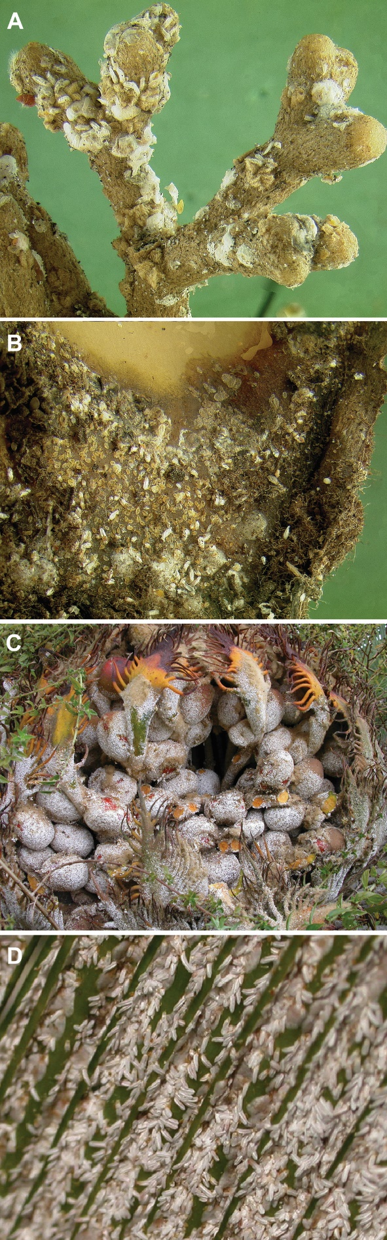
Fig. 1. Cycad aulacaspis scale, Aulacaspis yasumatsui, on the coralloid roots (A), cataphyll (B), leaves (C), and seeds (D) of Cycas revoluta. Photos by R. D. Cave.
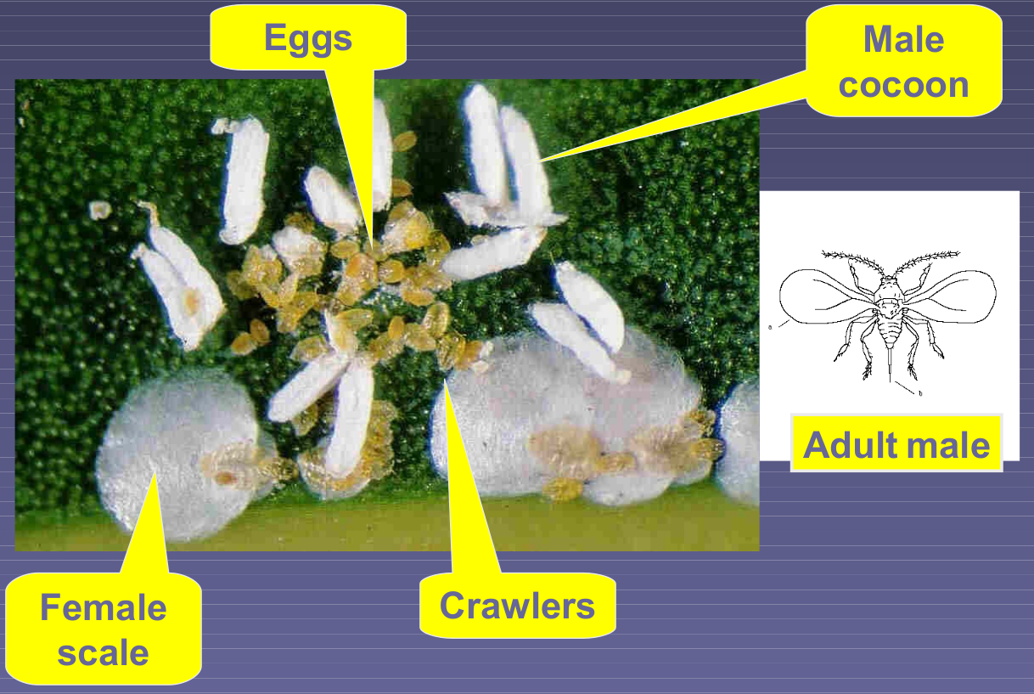
Fig. 2. The life stages of the cycad aulacaspis scale, Aulacaspis yasumatsui. Illustration by A. Moore.

Fig. 3. Number of Cycas micronesica stems per ha (all size categories) in 12 Guam habitats from 2005 to 2020. The inset shows results from 2008 to 2020 with smaller vertical axis range. Ordinates of markers with the same letter are not significantly different. Taken from Marler and Krishnapillai (2020).
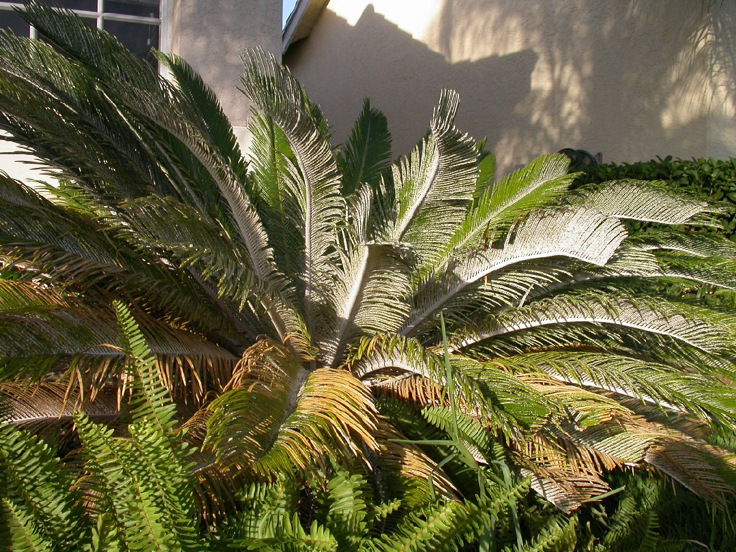
Fig. 4. Cycas revoluta with an intense infestation of the cycad aulacaspis scale, Aulacaspis yasumatsui. Photo by R. D. Cave.

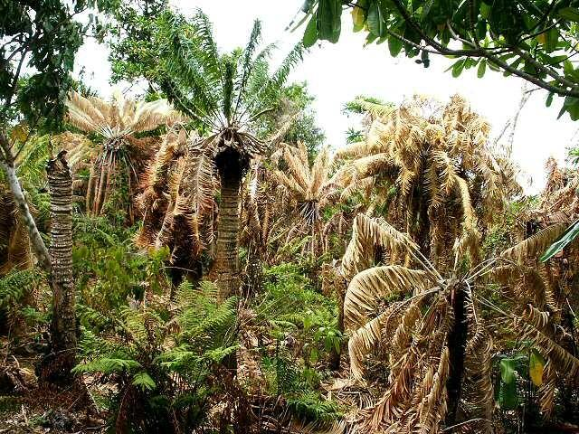
Fig. 5. Dead and dying Cycas micronesica at Tarague, Guam. Photo by Anne Brook.

Fig. 6. Rate of parasitism of cycad aulacaspis scale, Aulacaspis yasumatsui, by Coccobius fulvus in relation to female scale density on Cycas revoluta in Florida.

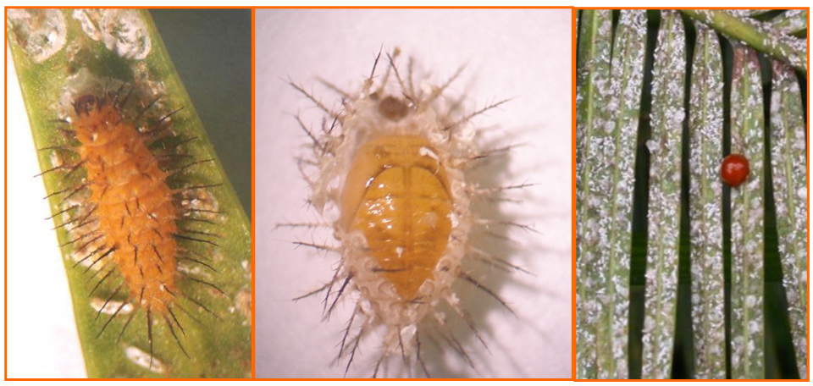
Fig. 7. Phaenochilus kashaya larva, pupa, and adult. Photos by R. D. Cave.

Fig. 8. Insects trapped on yellow sticky cards at Ritidian Point, Guam following field release of Rhyzobius lophanthae in February 2005. X axis runs from July 2005 through May 2006; Y-axis, in log scale, is the number of insects trapped per square meter per day.

